update the navigation bar and leave only these three menu options:
- How It Works
- Who Can Benefit from This Service
- Our Promise
update the text to:
Update the text to:
Receive fast, trusted second medical opinions from experienced Canadian specialists — without the need to travel outside Canada.
CHANGE THE VIDEO
CORRECT THE NAME
sunny privé

DELETE THIS 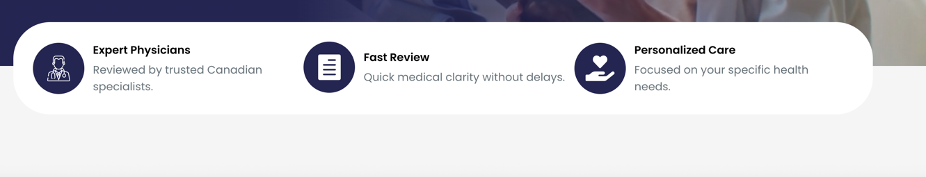

Replace the previous section with only 3 simplified steps:
- Request a Free Call
- Share Your Documents & Select Your Specialist
- Consult With Your Specialist & Get Referrals Within the Canadian System if Needed
DELETE THIS, IS BEING REPLACE FOR THE PREVIUS ONE.

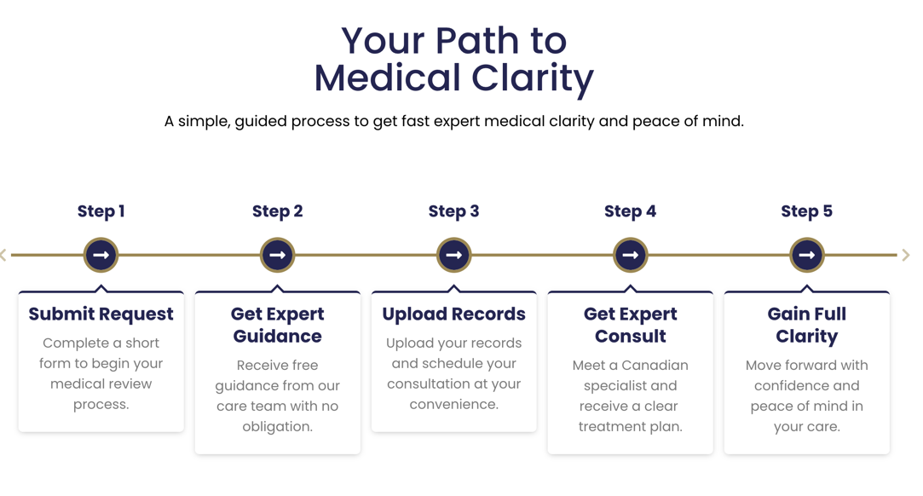

Please move this section below the header section, and use better images for ( life in uncertainty only)



PLEASE UPDATE THIS SECTION WITH THE FOLLOWING CHANGES:
- Only use 3 images in total and delete the other 3 images.
- Please ensure each image is relevant to the content of its corresponding section.
1. Fast Clarity Guarantee
Get a clear medical review within 3 days with actionable next steps.
2. Free Initial Guidance to Prepare for Your Appointment
Receive free guidance to help you understand the process, prepare your medical information, and feel confident before your specialist consultation.
3. Continuity of Care Without Leaving the Canadian Medical System
Stay fully connected within the Canadian healthcare system, with referrals and ongoing care coordinated inside the same medical network when needed.
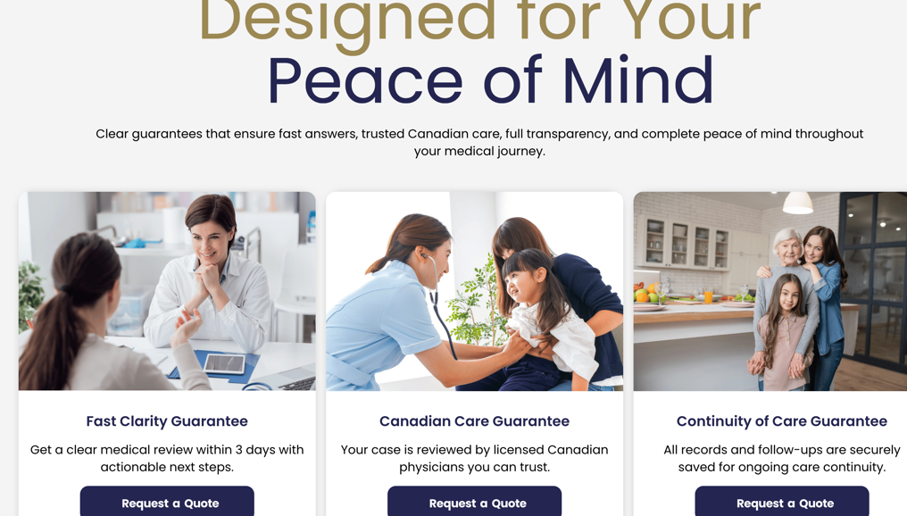

Delete: Designed By Sunsoftware
Please include 5-star Google reviews logo in the header section
Please adjust all text alignment to justified across the entire page

REPLACE THIS TEXT
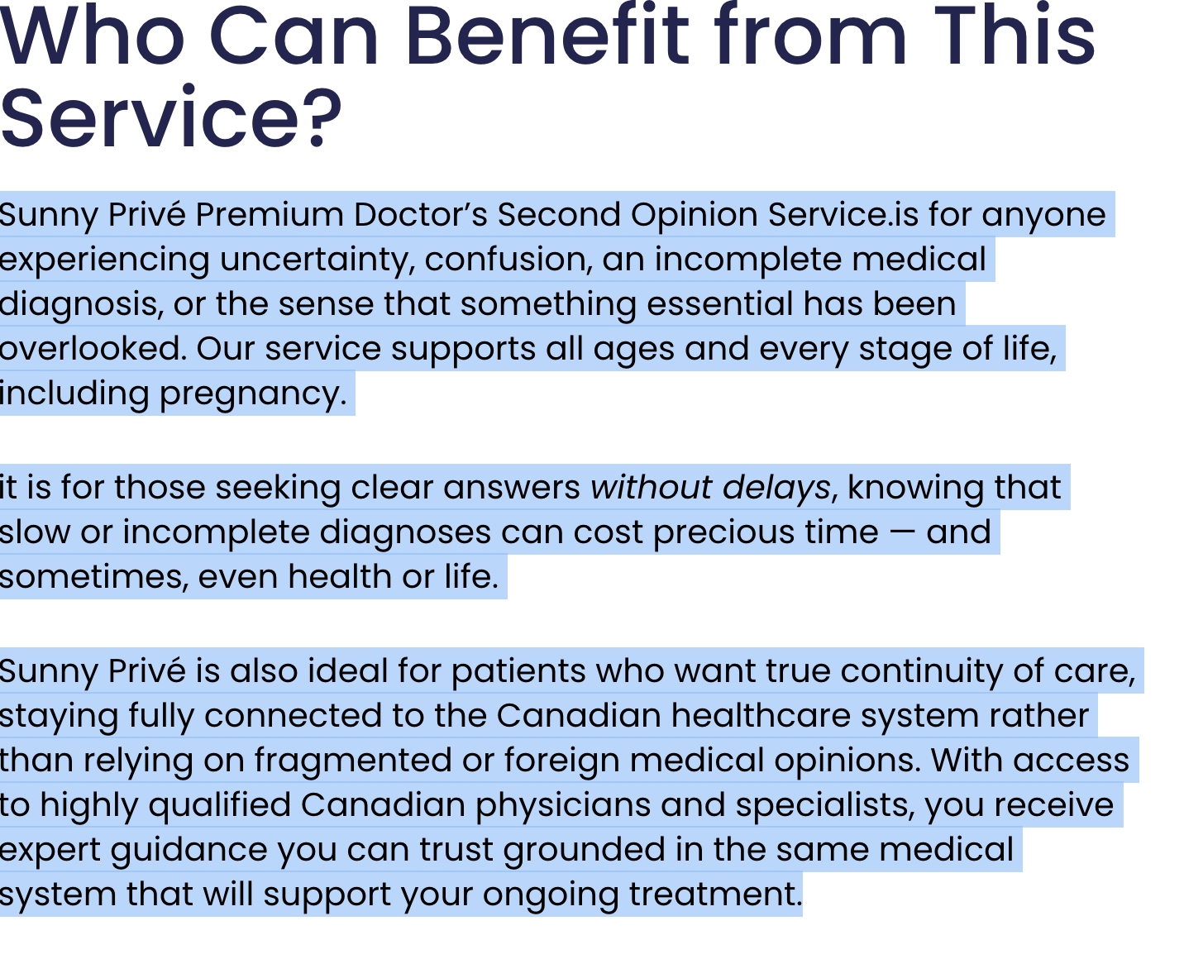
Sunny Privé is a Premium Concierge Doctor’s Second Opinion Service designed for anyone experiencing uncertainty, confusion, an incomplete medical diagnosis, or the feeling that something important may have been overlooked. Our service supports patients of all ages and every stage of life, including pregnancy.
We provide access to experienced Canadian physicians and specialists across all major medical specialties, delivering a personalized concierge experience focused on clear answers, trusted guidance, and continuity of care within the Canadian healthcare system.

